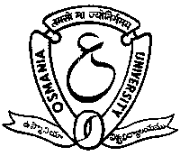

Dept. of Library & Information Science
Osmania University, Hyderabad

in Collaboration with

ICSSR Southern Regional Centre
and

United States Educational Foundation in India

Cordially invite you to One day Seminar
on

MANAGEMENT OF DIGITAL RESOURCES
on Thursday, the 30th September, 2004
at 9.45 a.m. at ICSSR Conference Hall, O.U. Library

Sri GIREESH SANGHI
Member Of Parliament (RS)
CMD and Managing Editor, Vaartha and AGA Publications
has kindly consented to be the Chief Guest

Dr. DAVID F KOHL
Dean & University Librarian, Emeritus
University of Cincinnati, U.S.A.
has kindly consented to deliver the address

PROF. M. MUTHA REDDY
Registrar
Osmania University, Hyderabad
will preside

Dr. J. Yadagiri Reddy Dr. Masood Ali Khan Prof. N. Laxman Rao
Head, DLIS, OU Director, ICSSR -SRC Seminar Director

