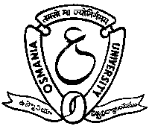

Dept. of Library & Information Science
Osmania University, Hyderabad

Cordially invite you to DLIS – IATLIS Annual Lecture 2004 on

LIBRARY CONSORTIA: PROBLEMS AND PROSPECTS
on Wednesday, the 29th September, 2004
at 11.00 a.m. at New Seminar Hall, Univ. College of Arts & Social Sciences, O.U.

Dr. C. S. RAO
Advisor (IT), Government of Andhra Pradesh
has kindly consented to be the Chief Guest

Dr. DAVID F KOHL
Dean & University Librarian, Emeritus
University of Cincinnati, U.S.A.
has kindly consented to deliver the Annual Lecture

Dr. N. Laxman Rao Dr. J. Yadagiri Reddy
Professor, DLIS, OU Head, DLIS, OU

