Aachen Colloquium on Click – A Split World
November 2004

What can ICTs do?
Perspectives from the Developing World

Subbiah Arunachalam
<arun@mssrf.res.in>
M S Swaminathan Research Foundation
Third Cross Street, Taramani Institutional Area
Chennai 600 113, India

I am asked to reflect on social and cultural consequences of technical development and try to answer a few questions:

- In what different kind of ways access to knowledge is modified in an information technology-based society that is dominated by technical resources?

- Does global exchange of information enable ubiquitous access to knowledge?

- By which means do information technologies contribute to the solution or intensify global and local problems?

- Which requirements arise from this problem for an IT-based society?

I shall try to answer these questions from the point of view of a Third Worlder.

Most other speakers at this colloquium are thinkers and experts known for their scholarship and academic achievements. I do not belong to the same league. I am not saying this out of humility; I am making a statement of fact. Then why am I here? Because I have felt the impact of information and communication technologies (ICTs) on the developing world and I have been working for many years to overcome the deleterious consequences of ICTs in the context of the poor and the marginalized. I wish to share with you what I have learnt through working in the field.

I am coming from India where we had a major election a few months ago. We are happy about the election for two reasons. One, contrary to what is happening in many parts of the developing world, democracy in India is vibrant and we have been holding free and fair elections consistently for more than 50 years. Two, despite outstanding achievements in the areas of high technology in general and information and communication technologies (ICTs) in particular, the ruling governments in the states of Karnataka and Andhra Pradesh belonging to two different parties have failed to return to power, largely because the rural poor voted against them. Thanks to rapid developments in indigenous capabilities combined with favorable policies by the governments in these two southern states of India, a number of IT industries and research laboratories – both Indian and multinational – sprung up, mainly in the capital cities Bangalore (referred to as the Silicon Valley of the East) and Hyderabad (half jocularly called Cyberabad). But these developments did not have a perceptible impact on the rural poor, who felt that they were neglected.

What can information and communication technologies (ICTs) do to help the poor? Can they do anything at all? That is a question that dominates the development discourse. If poverty has been so persistent that we could not eliminate it with all our efforts till now, how can the use of ICTs make a difference?

Poverty is much more than absence of money. Often generations in poverty lead people to a sense of utter hopelessness and deprive them of their sense of self-respect and dignity. They are deprived of access to essential assets and opportunities such as education, healthcare, employment, land and other natural resources, services, infrastructure and credit. They have little say in their polity and society. They are not empowered to participate in making the decisions that shape their lives. They become increasingly marginalized, excluded and vulnerable to exploitation. This exploitation manifests in several forms such as bonded labour, child labour, inadequate compensation for work if and when they get work, ill treatment and deprivation of basic rights. It will be naïve to believe that we can solve the problem of poverty by providing access to computers and telecommunication to the poor of the world.¹

We have always lived in an unequal world, but now the gap between information “haves” and “have-nots” is widening fast. As Kofi Annan² has noted, ‘there is a real danger that the world’s poor will be excluded from the emerging knowledge-based global economy.’ Virtually every new technology tends to exacerbate the inequalities that separate the rich from the poor.

The last few years have seen many initiatives that deploy ICTs in rural communities in many developing countries. Many world leaders have spoken in glorious terms about the tremendous potential of these new technologies in transforming the lives of the poor. “Technology doesn’t come after you deal with poverty, but is a tool you use to alleviate poverty,” says James D Wolfensohn, President of the World Bank. Says Mark Malloch Brown, Head of UNDP, “ICTs can help us reach the Millennium Development Goals including the goal of halving poverty by 2015.”

It is mastery over technology that enabled the early adopters of industrial revolution technologies to colonize and exploit the rest of the world. If the developing countries fail to take advantage of the new ICTs, the consequences could be far more serious. If we want technology to work for the poor we must make special efforts. In this talk I will describe from my own personal experience two widely different programmes where we are attempting to bridge the gulf that divides the rich from the poor through innovative use of information and communication technologies.

In the first part of my talk we will look at how we at the M S Swaminathan Research Foundation (MSSRF) are trying to harness ICTs as part of a holistic strategy for alleviating poverty in rural India. I will show why the emphasis should be on people and the public commons approach rather than on technology. In the second part, we will look at how the advent of new technologies has opened up the possibility for making knowledge distribution in science and scholarship a level-playing field. Here again the public commons approach is the key to success.

ICT and Rural Development
Shown in Figure 1 is a small hamlet near Pondicherry, where there is not a single brick and mortar house. The poor people here live in mud houses with a thatched roof made out of dried coconut leaves. And yet they have a dish antenna so every family can watch movies telecast by cable channels. Rural families, even if they are poor and cannot afford three meals a day, are ready to invest in technology if they find some value in it. These villagers, keen on seeing Tamil movies, found it cheaper in the long run to have their own community-owned antenna than to pay monthly rentals to a cable operator!

For the past six years [since 1998] MSSRF has been working in a cluster of villages (now numbering 12) in Pondicherry where we have set up rural knowledge centres [with a grant from the International Development Research Centre, Canada]. These knowledge centres are connected through a hybrid wired and wireless network and they provide information on agriculture, health, employment, weather, education, government entitlements, micro-enterprises training, etc. Although we use a variety of technologies, our focus is on the people, their context and their needs.

Figure 2 is a schematic of the MSSRF hub-and-spokes model. At the centre is Villianur, a small town, where we have set up the hub which is managed by MSSRF staff. There is a server and several personal computers. As the power fails often, we have installed solar panels to maintain uninterrupted operation of our services. It is here all the information – on weather, government schemes and entitlements, market prices, availability of seeds, fertilizers, pesticides, agricultural advisories, cattle diseases, etc. – is gathered and processed into databases stored in the server. Every morning the new set of information is transmitted electronically to the knowledge centres set up in 11 surrounding villages located within a radius of about 35 km. The processed information is transmitted from the server at Villianur to the computers in the spokes centres using one of two different technologies, viz. VHF two-way radio and spread spectrum.

At the spokes centres, local volunteers nominated by the village communities and trained by MSSRF provide information to whoever wants it. These centres are usually set up at public spaces such as temples, panchayat (local government at village level) buildings, and schools. Shown in Figure 3 is the knowledge centre at Embalam, which is managed by an all-women team of volunteers. Two of these women have been selected as Fellows of the Jamsetji Tata National Virtual Academy for Food Security, in recognition of their commitment to public good causes. Apart from providing information, these women have formed self-help groups and set up micro-enterprises. They have recently bought a tractor which they rent out to local farmers. This is the first time women in this village have ventured into such a business. In partnership with a women’s organization called Sagodhari (Sister), they provide counseling to women abandoned by husbands and women ill-treated by their in-laws. These women are truly empowered.

We also have a few knowledge centres in coastal villages, where the major occupation is fishing. One of the services the centres provide is to give accurate prediction of wave heights in the sea 36-48 hours in advance so fishermen can decide if they can venture out into the sea on a given day. Ever since this service was started, there has not been a single death in the sea. Unlike most other information that the knowledge centres provide, this information is not locally generated, but is downloaded from a US Navy website. Significantly, a whole range of technologies is involved in providing this information to fishermen. The US Navy obtains the information by satellite observation using a range of high tech devices; the MSSRF staff at the hub download it from the Internet and transmit the information as a multimedia package – the picture in colour (see Figure 4), a written statement and an oral report – to the coastal centres electronically; at the coastal centre the local volunteer broadcasts the voice clip over a public address system several times during the day and puts up the picture and the statement on the notice board. A classic example of blending the old and the new technologies to serve a specific end. We also obtain potential fishing zone information from a Department of Ocean Development laboratory by Fax and announce the information (latitude, longitude, direction, depth, etc.) in a manner the local fishermen would easily follow.

Over the years we have found that these centres and their volunteers and the local communities can benefit a great deal if a number of activities are built around the knowledge centres. For example, some of our volunteers took training in checking eye defects from the well-known Aravind Eye Hospital. They check the villagers’ eyes and if they need care take a picture of the eye with a web camera and send patient details as email attachments to the hospital. When the doctor is free, he looks at them and informs the volunteer which of the patients need to come to the hospital for free treatment. Among other activities built around the centres are training in several micro enterprises, computer hardware and software, workshops on indigenous medicine and veterinary medicine, and holding meetings with banks and insurance companies.

What makes this experiment in using access to information to leverage rural development and poverty alleviation successful? There are many reasons. First, the sense of ownership of the programme by the local community. Much of the collection of information (such as weather, market prices, availability of agricultural inputs, etc.) is carried out by local volunteers. Says the Cambridge University economist Partha Dasgupta: “Developing the local capacity to collect and distribute information is integral to any sustainable development programme.”³ Second, the knowledge centres have many partners who help them in multiple ways. These include agricultural research centres and field stations, veterinary colleges, hospitals, experts in indigenous medicine for men and animals, and government departments. Third, technologies are not seen as a technical solution on their own but as enablers in a process of local prioritization and problem solving.⁴ Fourth, the centres enable two-way communication; the villagers not only get useful information (obtained from experts) when they need it but also can communicate their problems which when transmitted to the experts can reorient their research. Prof. Bruce Alberts, President of the US National Academy of Sciences, after his third visit to these centres, told the Fellows of the Academy: “If our Academy wants to make a strong contribution to sustainable development through science and technology, it is in nations like India that we should search for models, not in nations like ours.”⁵

As we gained experience running these knowledge centres and providing information that the villagers could use in their daily life, we wanted to expand the programme to reach a larger audience. We took three different, but related, initiatives.

New initiatives
We set up the Jamsetji Tata National Virtual Academy for Food Security and Rural Prosperity (NVA) with funding from India’s leading philanthropic foundation, the Tata Trusts. NVA has a hierarchical structure with the state level hub gathering and processing information from experts (universities, research laboratories, meteorological office, etc.) and feeding it to block level hubs, which in turn are connected to village knowledge centres. Please see Figure 5. In collaboration with OneWorld International and their partners in Africa, we set up an Open Knowledge Network.⁶ Village communities connected to the network can exchange data, audio and video programmes, etc. via WorldSpace satellite or internet (Figure 6). Much of the knowledge exchanged pertains to indigenous plant-based medicine (for both humans and animals) and traditional agricultural practices. Recently the village communities and our volunteers have started experimenting with radio. As the Indian government does not permit community radio, they are working with All India Radio’s Pondicherry studio to broadcast their content. They are also experimenting with Internet radio in collaboration with OneWorld South Asia. In collaboration with the Indian Space Research Organization, we are now setting up additional centres called Village Resource Centres. We use transponders of Indian satellites to connect regional hubs set up in villages/ small towns located several hundred kilometers away. This programme was inaugurated by the Indian Prime Minister Dr Manmohan Singh on 18 October 2004 through teleconferencing. On that occasion a heart patient at Thiruvaiyaru and his physician obtained help from a cardiac surgeon from a medical university in Chennai.

We have recently formulated Mission 2007: Every Village a Knowledge Centre, for spreading the ICT-enabled knowledge revolution to every one of India’s more than 637,000 villages by 15 August 2007, the 60th anniversary of India’s Independence. To achieve this goal we have mobilized the power of partnership by forming a National Alliance which includes academia, government departments, civil society organizations, banks, private corporations, industry associations, etc.

We also conduct an annual South-South Exchange Travelling Workshop wherein 20-25 development workers from Africa, Asia and Latin America travel with our team from village to village, visit our knowledge centres and other project sites, meet with local communities and our volunteers and learn from one another.⁷ The participants continue to exchange knowledge and experience through an electronic discussion list called C3Net (short for Community Content Creation Network, c3net@dgroups.org) and enhance every one’s ability to contribute to their projects.

Thus our experience has shown that ICTs can be used to facilitate awareness and participation in social and economic processes and to make a difference in the lives of the rural poor and empower women, if we know how to go about it.

How ICTs can bridge the gap in science
One of the main purposes of science is the production of new knowledge. And in producing knowledge scientists do not work in isolation. They build on each other’s work. As Newton said, “I stand upon the shoulders of giants to see further.” Scientists exchange knowledge primarily through research papers published in journals. In the earlier era, there were not many journals and every institution could subscribe to a very large proportion of journals relevant to their research. Surely, there must have been some delay in getting the journal issues in countries in Asia as most journals were published in Europe and were sent out by sea. But with time, the number of journals increased and libraries found it difficult to subscribe to all the journals they needed. The subscription prices of journals also increased at rates far higher than the general inflation for several years, making it difficult even for affluent institutions in the West to provide satisfactory service to their clientele. As a consequence, there arose a big gulf between the advanced countries and the rest of the world in the matter of access to scientific information.

Harnad et al. have estimated that there may be around 24,000 scholarly science and technology journals publishing something like 2.5 million articles each year.⁸ Until recently, all the libraries of India combined had subscriptions to only around 1,500 of these journals. And many of the smaller colleges and institutions subscribe to fewer than hundred journals. The situation is even worse in many parts of Africa. So, if information is key to science development, how can we expect researchers in developing countries to perform good science at the level of someone at Aachen, Harvard or Oxford?

To be a scientist in a developing country is to be on the periphery of world science - one's work goes unnoticed. A scientist in a developing country, who invariably works under adverse conditions, needs to achieve a lot more to win recognition than those who work under much better conditions in developed countries. It is widely believed that if an editor of a scientific journal had to choose between two papers of equal merit, he would choose the one from Harvard in preference to the other from Hyderabad.⁹
Thus developing country scientists suffer from the twin problems of poor access to information and lack of visibility.

The advent of new technologies such as computers and electronic handling of information made the situation even worse as most scientists in the developing world did not have access to these tools. Surely, under difficult circumstances, one computer can be shared by ten or twenty people, or even more. But one problem would still remain. How are we going to provide inexpensive Internet access to scientists and scholars in poor countries? The transition to electronic publishing and dissemination of knowledge runs the risk of widening the gap between the developed countries and the developing countries, unless computers and Internet access are made available.

Thanks to men like Gandhi, Martin Luther King, Nelson Mandela and Desmond Tutu, we have abolished skin-colour-based apartheid, but are letting the new ICTs to create an information-access-based apartheid.

As is evident from our own experience in using ICTs for alleviating poverty in rural India, intelligent human intervention alone can help us realize the advantageous potential of new technologies.

The advent of new technologies, especially the Internet, has opened up instantaneous and inexpensive ways of disseminating scientific knowledge. Scientists and librarians in the advanced countries responded to the “serials crisis” by mounting low cost and toll-free alternatives to commercial journals as well as open access archiving. Long before the “serials crisis” was felt the physicists took advantage of these technologies. They established the now famous Los Alamos ‘arXive’ [www.arXiv.org], a central archive where researchers anywhere from the world can deposit their pre-prints and post-prints, about 14 years ago. It has now moved, along with its founder Paul Ginsparg, to Cornell University.

If every scientist deposits his / her papers in such open archives then anyone anywhere with Internet connection can access all papers at virtually no cost. Thus, the Internet and World Wide Web, unlike any other technology before, are capable of leading us to a more democratic future.

Open Access Initiatives

Many organizations have come forward to support and promote open access. These include the Open Society Institute, Budapest Open Access Initiative (BOAI), Association of Research Libraries (ARL), SPARC (the Scholarly Publishing and Academic Resources Coalition), the Wellcome Trust, CERN, Howard Hughes Foundation and the Public Library of Science. A group of scientists in Europe came up with the Berlin Declaration supporting open access publishing and open access archiving.

Bruce Alberts has pleaded for connecting all scientists to the World Wide Web, where necessary, by providing subsidized Internet access through commercial satellite networks.¹⁰

Today there are several centralized archives of full text papers as well as more than two hundred institutional archives and all of them are interoperable. There is resistance from both commercial publishers and society publishers. Also, there is still confusion in the minds of many scientists about the role of institutional self archiving. However, more than 92% of about 9,000 journals surveyed permit authors to archive their papers.

As more and more scientists and institutions around the world start archiving their papers, access to information will become a level playing field. Besides, the work of developing country scientists will have much greater visibility and impact. It has been shown that research papers in fields ranging from physics to computer science that are available on open access are cited far more often than those which are available only through toll-access journals.^{11,12}

For a comprehensive understanding of the open access movement and its tremendous advantages, one may look up ‘Open Access News’, a blog maintained by Peter Suber
[www.earlham.edu/~peters/fos/fosblog.html].

Conclusion
Thus ICTs used innovatively can help bridge the gap between the rich and the poor be it in the area of rural development and poverty alleviation or in the field of accessing research information by scientists. Unlike other technologies that came before it the World Wide Web has the potential to democratize information access and make the field truly level playing. Here the
notion of ’public commons’ is of paramount importance. Tim Berners Lee and CERN did not patent the World Wide Web. Linus Torvald gave Linux free to the world. Every scientist who writes research papers for publication in journals wants his work to be read (and cited) by a very large number of scientists. After all, as John Ziman said, science is ‘public knowledge’.

Can increased global exchange of information lead to ubiquitous access to knowledge? Perhaps yes in the case of scientists and scholars. In the case of the world’s rural poor, often their knowledge needs are locale specific. Even so, exchange of free and unhindered flow of information will certainly help.

If ICTs are becoming the defining paradigm of our times, it is imperative that we learn to use them as an ally in the equity movement.¹³ The question before us is “Can we retain the virtues of olive tree societies while taking advantage of the Lexus technologies?” Do we have reasons to hope that the electronic revolution that is currently widening the information gap will eventually narrow, and perhaps even abolish, the gap?
The answer is not in the domain of technology, but on the choices we make.

No doubt, technology has the potential to transform the world. But the benefits of technology can reach the marginalized, both at the level of the rural poor and at the level of information-starved scientists of the developing world, only if we build institutions that can nurture the public commons approach and unleash the power of partnership. That is why I am a strong supporter of organizations such as the Global Knowledge Partnership (GKP), OneWorld and IICD.

References
1. Arunachalam, S. (2004) “Information and communication technologies and poverty alleviation” Current Science, Vol. 87, 960-966.
2. Annan, K. (2002) Kofi Annan’s IT challenge to Silicon Valley; http://news.com.com/
2010-1069-964507.html
3. Dasgupta, P. (2000) “Food production, population growth, and environmental security” in Debates on issues of our common future, edited by Wilhelm Krull, Velbruck Wissenschaft, Welerswist, pp. 128-132.
4. Chapman, R. (2005) “ICT enabled knowledge centres and learning in the global village” in The Third South-South Exchange Travelling Workshop 2004 – Workshop Report, MSSRF/ PR/ 05/ 59 (M S Swaminathan Research Foundation, Chennai)
5. Alberts, B. (2004) “A world that banks on science” Presidential Address at the 141st Annual Meeting of the National academy of Sciences, USA, Washington DC, 19 April 2004.
6. http://www.openknowledge.net/
7. MSSRF (2005) The Third MSSRF South-South Exchange Travelling Workshop, Workshop Report, MSSRF/ PR/ 05/ 59, [http://www.globalknowledge.org/gkps_portal/index.cfm?menuid=411]
8. Harnad, S., Brody, T., Vallieres, F., Carr, L., Hitchcock, S., Gingras, Y, Oppenheim, C., Stamerjohanns, H., & Hilf, E. (2004) The Access/Impact Problem and the Green and Gold Roads to Open Access. Serials Review, Vol. 30 (4).
[http://dx.doi.org/10.1016/j.serrev.2004.09.013].
9. Anonymous (1997) “It is not what you know – If there are biases in scientific publication editors must take the blame” unsigned editorial in New scientist, No. 2106, (1 November 1997) p.3.
10. Alberts, B. (1999) “Science and the world’s future,” Presidential address at the 136th Annual Meeting of the National Academy of Sciences, USA, Washington DC, 26 April 1999.
11. Lawrence, S. (2001) “Free online availability substantially increases a paper's impact” [http://www.nature.com/nature/debates/e-access/Articles/lawrence.html].

12. Harnad, S. and Brody, T. (2004) “Comparing the Impact of Open Access (OA) vs. Non-OA Articles in the Same Journals” [http://www.dlib.org/dlib/june04/harnad/06harnad.html].
13. Arunachalam, S. (2000) “Information and knowledge in the age of electronic communication: A developing country perspective” in Debates on issues of our common future, edited by Wilhelm Krull, Velbrück Wissenschaft, Welerswist, pp. 231-250.

Figure captions

Fig. 1. A hamlet in Pondicherry. People may be poor, but they are ready to invest in technology if they see some value in it. Here you see a dish antenna that helps villagers see films on their television sets.

Fig. 2. The hub-and-spokes model used to link the knowledge centres in the Information Village Research Project of MSSRF in Pondicherry.

Fig.3. The all-women Embalam knowledge centre.

Fig. 4. The wave height information downloaded from a US Navy website

Fig. 5. The structure of the National Virtual Academy.

Fig. 6. Open Knowledge Network connecting the rural poor in Africa and India.

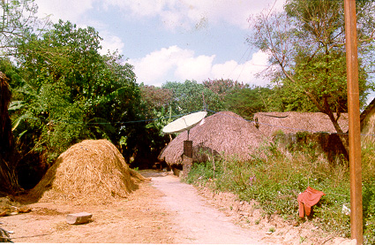

Figure 1

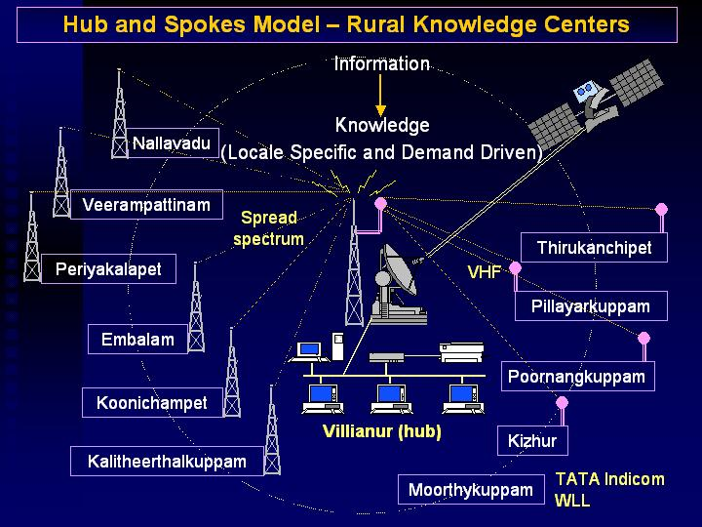

Figure 2

Figure 4

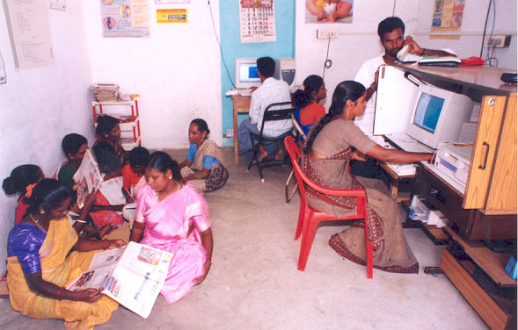

Figure 3

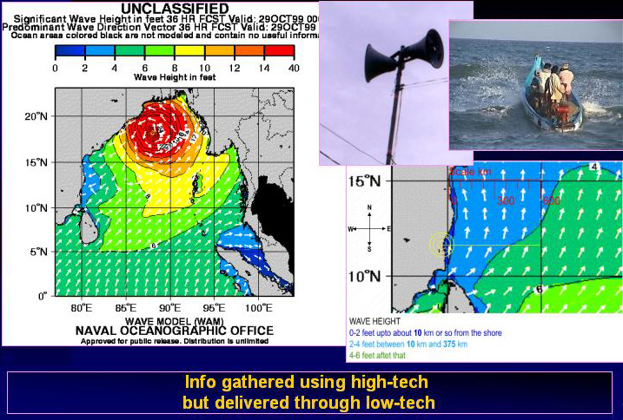
http://www.nemoc.navy.mil/Library/Metoc/Indian+Ocean/Bay+of+Bengal/Models/Swaps/Sig+Wav+Ht+and+Dir+Series/index.html

Figure 4

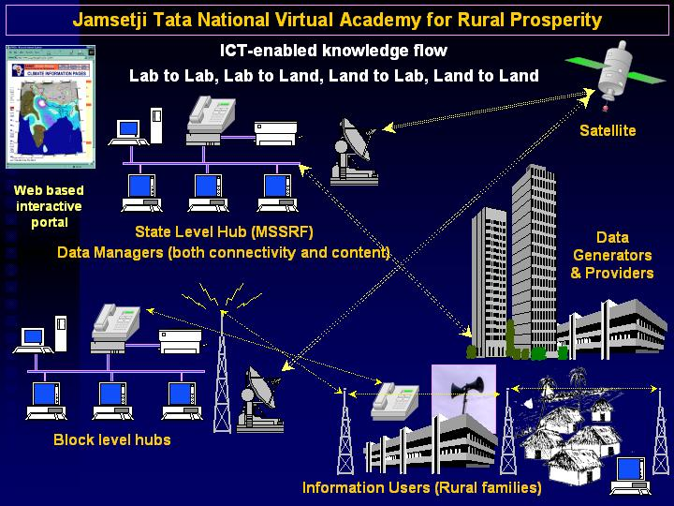

Figure 5

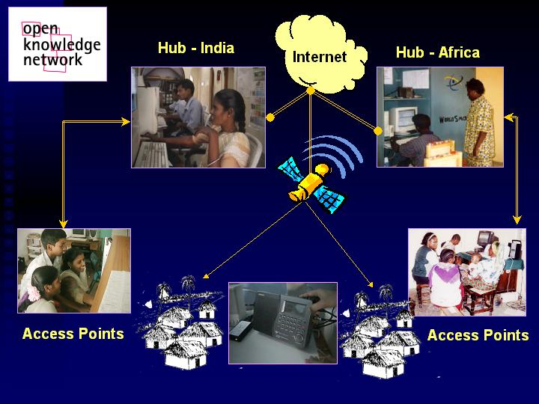
Figure 6

