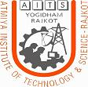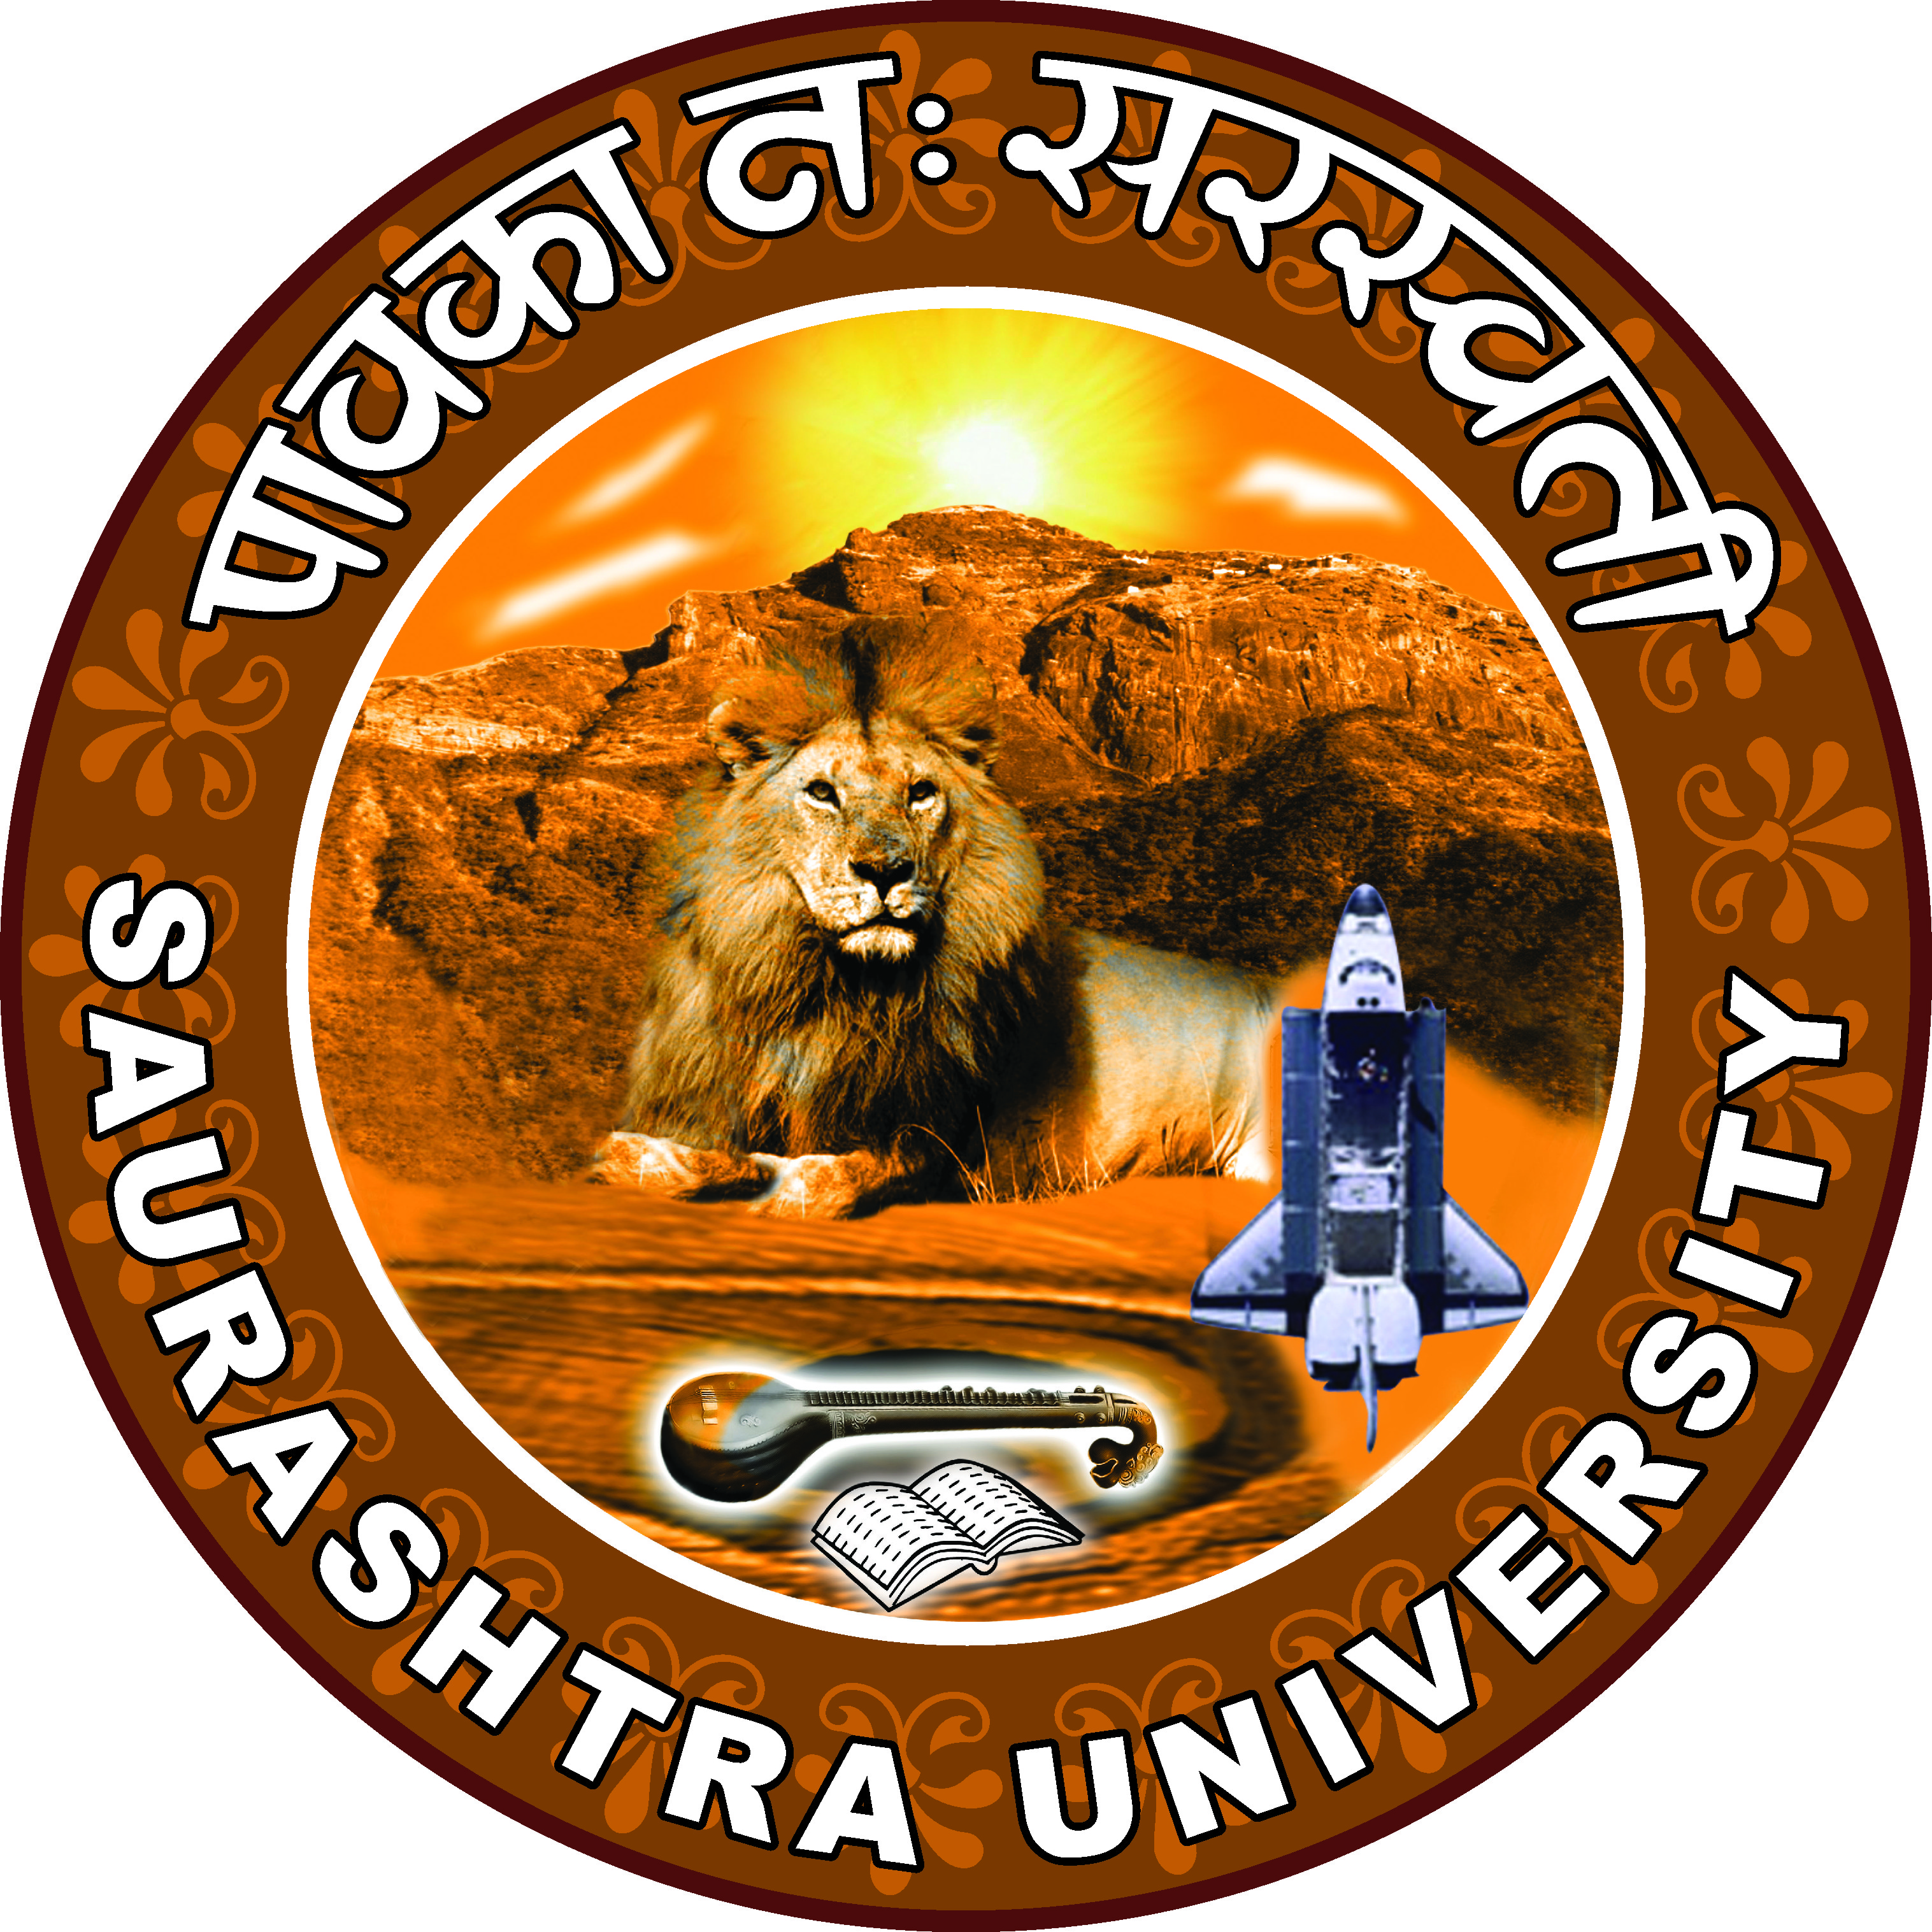

INFORMATION LITERACY FOR LIBRARIANS

A Two Day Workshop for Librarians of Saurashtra Region

Organized by

Library and Learning Centre (LLC),
Atmiya Institute of Technology and Science (AITS)
&
Saurashtra University

Date: 1st & 2nd August, 2009

Venue:
Auditorium,
ATMIYA INSTITUTE OF TECHNOLOGY AND SCIENCE

“YOGIDHAM GURUKUL”
Kalawad Road, Rajkot – 360005
Ph.: +91 – 281-2562681, Fax: +91-281-2563952
Email: sdtank@aits.edu.in, Web: www.aits.edu.in

About the Workshop
The workshop is being conducted keeping in mind the current trends in the Library and Information Science Profession. The topics have been selected in a way that all the Librarians and LIS professionals who attend this workshop will Learn about Information Literacy concept and also get empowered to create one for their users. The focus is on the Internet and the Free and Open access resources with the help of which one can provide good number of services to its users in current times.

The Benefit of attending the workshop
There will be practical training provided on using Internet Tools, Free and Open Source Software for Library Management & building Institutional Repositories, the use of Web 2.0 in enhancing the Library Services, Information about Library Networks and why one should join them, Library Budgets and funding by Government and Self – Finance Institutes. Thus useful for all levels of LIS professionals.

Lab exercises
The Practical session will be provided in 4 different labs and participants can choose the area they would like to practice on:
- Internet Tools
- Web 2.0
- Newgenlib (Integrated Library Automation Software)
- DSpace (for building Institutional Repository)

Who should attend?
Library and Information science Professionals of Academic and Corporate Libraries, Students of LIS, IT professionals

How to register
Fill in the registration form and send it to the below address latest by 29th July 2009. For Spot Registration please confirm your participation will registration In-charge.

Accommodation
For Participants who need accommodation, the arrangement will be done based on the demand and the charges will have to be paid separately.
The Topics
- Information Literary
  - Information Literacy (Introduction, Need, Purpose, Importance, Models)
  - Examples of ILP’s
- Internet Tools for Librarians
  - Searching the web & Evaluating the Internet resources
  - Open access e-resources (E-journals, E-books, Open Courseware’s, Institutional Repositories)
  - E-consortia’s awareness (UGC-INFONET, AICTE-INDEST Etc.)
- Library Networks (Membership Benefits, Services provided, Charges)
  - INFLIBNET
  - DELNET
  - MANLIBNET
  - ADINET
- Web 2.0 for Library and Content Management System
  - Creating a Blog
  - CMS using Web 2.0
  - RSS Feeds
- FOSS for Library Management
  - NewGenLib (Library Automation Software)
  - Dspace (For building Institutional Repositories)
- Practical Session
- National Bodies for Grant-in-aid & self finance (UGC, AICTE)
  - UGC Schemes for Funding of Libraries
  - Library Budget for Self-Finance Colleges

Resource Persons:
1. Dr. T.S. Kumbar, Librarian, DAICT
2. Mr. Anil Kumar, Librarian, IIM A
3. Mrs. Nishtha Anil Kumar, Librarian, PRL
4. Dr. Kautilya Shukla, Librarian
5. Mr. Kamaljeet Lakhtariya, Lecturer, AITS
6. Ms. Trupti Limbani, Lecturer, VSC

About AITS
Keeping in mind the concept of VASUDEV KUTUMBAKAM (Global Village) competitive international scenario with Hi-Tech advancement, the need of industries in Gujarat and beyond and the growth of industries through modern information Technology, Yogi-devine society has promoted Atmiya Institute of Technology and Science in the year 2000-2001. The institute presently runs six UG courses in degree engineering and two PG courses. The Institute has been accredited by NAAC in the year 2008.

About LLC, AITS
The Central Library of Atmiya Institute of Technology and Science called as the LIBRARY AND LEARNING CENTRE (LLC) is situated in the Center of the whole setup. It is built up on two floors having elegant, welcoming ambiance and is centrally air conditioned. It has a collection of more then 30,000 volumes of books across the subjects that the institute offers; it also has an online subscription to IEEE, IET and ASME e-Journals through the INDEST-AICTE consortium and print subscription to around 130 different serials across the subjects of Engineering, Computer Science and Management.

Address for Correspondence
Mrs. Sheetal D Tank,
Librarian,
Atmiya Institute of Technology and Science
“YOGIDHAM GURUKUL”, Kalawad Road,
Rajkot – 360 005
Contact Numbers:
Ph.: +91 – 281-2562681, Fax: +91-281-2563952
Extn. 1212, 1211, 1217, 2240, 2201

About Saurashtra University
Saurashtra University, established on 23rd May, 1967, is situated in Rajkot city of the Saurashtra region of Gujarat State, India. The campus of the University is spread over 410 acres of land. The jurisdiction of the University includes Amreli, Jamnagar, Porbandar, Rajkot and SurendraNagar districts. The University has 242 colleges affiliated to it imparting Undergraduate and Post graduate education. It has been distinctly fortunate to avail of the erudition and academic experience of various distinguished educationists, beginning with the late Professor Dolarrai Mankad, the founder Vice Chancellor of the University.
In the last few years, the University has made unique strides in the following areas: Generating financial resources (where it has been indebted to the renowned philanthropist Dr. Dipchand Gardi, who has till date generously donated a sum of 20 million Rupees), infra structural development, and facilitation of academic growth and administrative efficiency. “The National Assessment and Accreditation Council (NAAC) has Re-accredited the university with Grade 'B' in 2009." (CGPA 2.93)
Saurashtra University has 26 Departments on the campus that are described in detail in the pages to come. Besides these Departments, the University provides higher education through Post-Graduate Centers and Institution spread all its jurisdiction area. On the campus, it has facilities like internet connectivity, complete infrastructure for all research activities, Transit House for international students, a well equipped Central Library, Career Counseling and Development Center, Center for Women’s Studies, Bank, Post Office, Canteen, Playground, Gymnasium, Professor’s Quarters, Quarters for administrative staff, two beautiful check-dams, Botanical Garden, Art Gallery, Day-care Center, Adult Education Center, Academic Staff College, hostels for boys and girls, Guest house, garden for Ayurvedic medicinal plants, Radio station for Gyanvani, a Geo-magnetic observatory, an automated Weather Station, IGNOU’s Regional Center and its Study Center, with major road connecting all these buildings constructed of reinforced concrete cement.
Proposal of SAULIBNET (SAUrashtra LIBrary NETwork): an effective tool in upgrading the present status of the academic Libraries in Saurashtra Region.

In this workshop we will be putting forward the proposal of forming the SAULIBNET.

The objectives of forming this Library Network would be as follows:
- To facilitate and promote sharing of resources among academic libraries in Saurashtra Region
- To offer professional and technical guidance to member Libraries on Selecting, storing , sharing and disseminating of Information
- To Coordinate among member libraries and help have a good collection development and reduce un-necessary duplication wherever and whenever necessary.
- To develop Union databases of periodicals, special collection and specialists in institutions of Saurashtra region
- To create awareness through Seminars/ Workshops/ Training programmes to member professionals on current trends in the profession.

Useful Contact Numbers for assistance:

For Registration
Mrs. Roopal Dave - 09898729639
Mrs. Raksha Bhatt - 09429243622

For Accommodation
Mr. Himal Dobariya - 09979466811
Mr. Nilesh Bhatti - 09427562787

For assistance & Information
Mrs. Chetna Gohil - 09879372269
Mrs. Kanak Balodi - 09327339718

For SAULIBNET
Mr. Nilesh Soni - 09426737071
Mrs. S. D. Tank - 09824295001

