How to Secure PDF Documents ?

How to Create a PDF Document

Requirement:
Adobe Acrobat Writer (Distiller)

Procedure:
Any documents or images can be easily converted to adobe acrobat file (PDF File) using a print command and selecting the Adobe distiller.

How to Secure PDF Files

Requirement:
Adobe Acrobat Writer (Distiller)

Securing PDF Files
PDF documents can be secured for following options
- Printing
- Changing the document
- Content copying and Extraction
- Adding or changing comments and form fields

To secure any of the above options follow the following procedure

Select Document Security from File Menu of Adobe file.
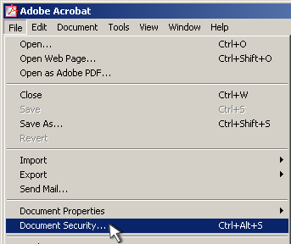

When the Document Security window appears, select "Acrobat Standard Security."
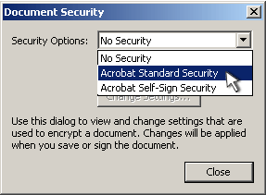

When the Standard Security window appears, check the box for "Password Required to Open Document." Enter the User Password. Then check the box for "Password Required to Change Permissions and Passwords." Enter the Master Password.

You can increase the encryption level from 40-bit to 128-bit, but your audience will need to have at least version 5 of Acrobat to read the file.
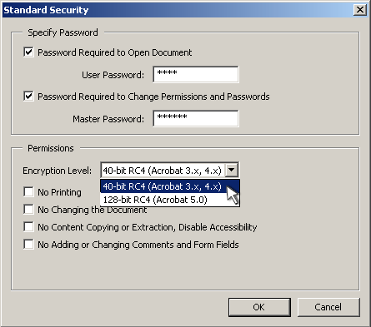

Check the boxes which are to be secured. For e.g., if printing to be protected check “No Printing” check box, if copying to be protected check “No Content Copying or Extraction Disable Accessibility”.
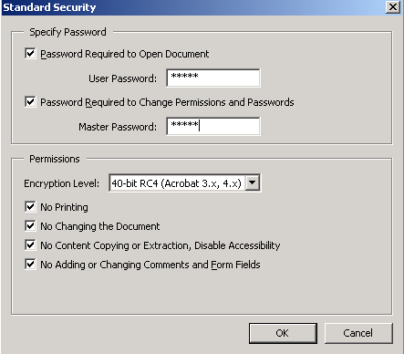

When you have applied all the desired security settings, click "OK."

A window opens asking you to confirm the password to open the document. Confirm the password.
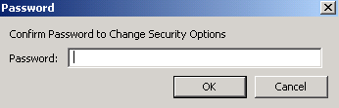
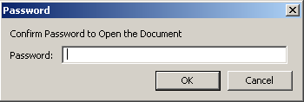

Another window opens asking you to confirm the password to change the security options. Confirm the password to secure the PDF file.

