National Conference
on
ADVANCES IN KNOWLEDGE MANAGEMENT
(NCAKM’ 10)

8 – 9 March 2010
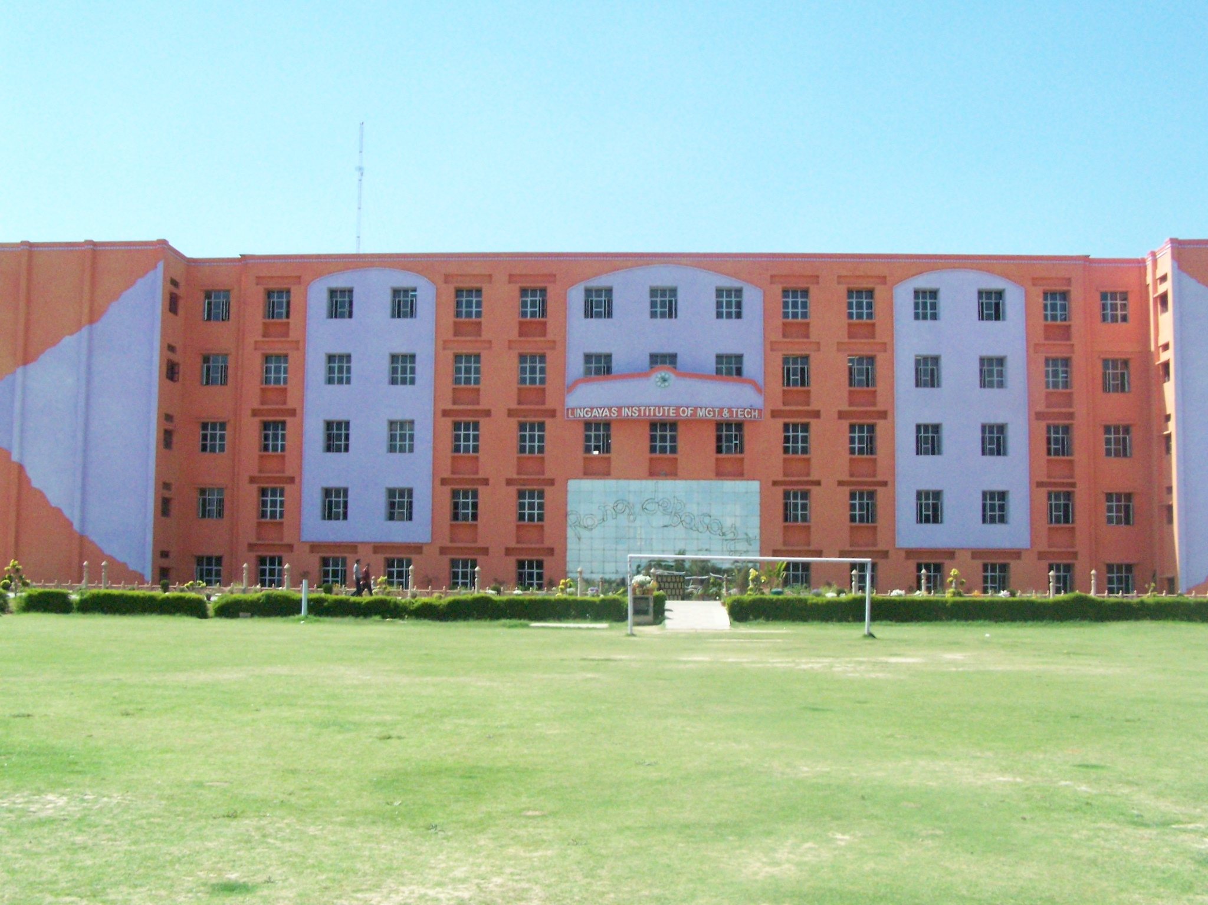

Being organized by

Dept. of Computer Science & Engineering
and
Library Science Centre

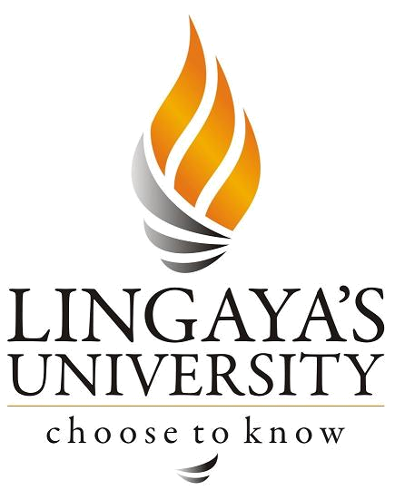

Lingaya’s University
(Deemed to be University under Section 3 of UGC Act, 1956)

Nachauli, Old Faridabad – Jasana Road, Faridabad 121 002, Haryana
Ph: +91 (129) 220-1008, 220-1009
Web: www.lingayasuniversity.edu.in, Email: cselimat2009@gmail.com
OBJECTIVE
The primary objective of NCAKM’10 is to establish an effective channel of communication between theoretical researchers and practitioners. The theoretical research outcome provides necessary support to practitioners in the design and development of intelligent systems that will handle the issues related to knowledge acquisition, storage, retrieval, processing, and visualization. It is also expected that it would provide platform to address difficulties faced by the practitioners in using the theoretical results provide feedback to the theoreticians to revalidate their models. NCAKM’10 thus meets the demand of both theoretical and applied researchers in knowledge management which in turn provides foundation to work in the area of artificial intelligence.

The conference provides a platform and enables interaction among Digital Library Experts, Researchers, Academicians and Students, Adoption and implementation and Utilization of Digital Libraries and their future implications towards shaping information paradigm. To enable developed and developing countries to bridge the digital divide through knowledge sharing. To provide an opportunity to identify the strengths and gaps in the library system and to suggest new models, policies and mechanisms for reshaping the traditional libraries into next generation libraries.

CALL FOR PAPERS
The contributors can send their papers on any of the themes and sub themes besides any topic of their interest relevant to the themes or sub-themes. Guidelines for contributors:
- The paper should be submitted simultaneously for approval to the Editorial Board by the date announced.
- The full paper will be reviewed by the Editorial Board and the comments, if any, of the Board will be communicated to the author/s for necessary action.
- The authors can send their papers as an e-mail attached on ncakm2010@gmail.com
- The original papers submitted should be typed on MS Word with proper citation as IEEE format. The text should be typed single-spaced, A4 page size, 12 point font size, Times New Roman font type, in word or RTF format. The word limit for each paper is 4000 words. All papers should be written in English for acceptance in the conference presentation.
- Authors should send the copyright form by post duly signed by them declaring that the paper is original and has not been published anywhere.
- Only selected papers should be published in compendium and the author will be invited for presentation in conference. Presentation will be expected to be of 10 minutes on power point presentation followed by discussion.
- The text of conference paper must comprise: Title of the paper, Name(s) of author/s, their Institution, city and country. Abstract of approximate 200 words, summarizing the presentation along with key words, Full Text with proper citation and References.

TOPICS FOR PAPER PRESENTATION
- Knowledge Representation Issues
- Knowledge Management and Storage
- Visualization of Knowledge
- Digital Library Systems
  - Technological Innovation and E-Publication
  - Security Surveillance, Magnetic Strips and RFID
  - Information Storage and Retrieval for global access
- Application of Soft Computing Approaches
  - Fuzzy logic
  - Genetic Algorithm
  - Neural Network
  - Bayesian Networks
- Expert Systems
- Natural Language Processing
- Image Processing
- Web Analytics
- Content Based Image Retrieval
- Data Mining Tools & Techniques
- Multimedia knowledge mining
- Learning and Adaptive Systems
- Bioinformatics
- Data Centres

REGISTRATION FEE (PER PARTICIPANT)
One registration is applicable for two days. The charges include transportation, meals, refreshment, snacks, etc.
Participants from Corporate / Academics and R & D Institutions | Rs. 1200/-
U.G. / P.G. Students and Research Scholars | Rs. 600/-
To submit your research paper: ncakm2010@gmail.com
Participants who wish to avail hostel accommodation at LU should book their rooms well in advance. They may contact the organizers at cselimat2009@gmail.com by email or Mr. Manoj Kumar Jain or Ms. Gauri Sharma.

IMPORTANT DATES
Submission Deadline | 10 Jan 2010
Notification to Authors | Until 31 Jan 2010
Final Camera-Ready Submission and Early Registration (1st date) | Until 15 Feb 2010
Late Registration (1st date) | 20 Feb 2010
Conference: LU, Faridabad | 8 – 9 Mar 2010

Hon’ble Patrons
Prof. G. V. K. Sinha, Chancellor, LU
Dr. Picheswar Gadde, Pro-Chancellor, LU
Dr. K. K. Aggarwal, LU

Advisory Committee
Dr. S. Mukhopadhyay, Pro Vice Chancellor, LU
Dr. A. K. Soni, Dean (Info. Sc.), LU
Dr. Khurram Mustfa Farooki,JMI, Delhi
Dr. M. Hanumandlu, IIT, Delhi
Dr. N.K.Verma, IIT, Kanpur
Dr. J.N. Gautam, Dean, Jivaji Univ., Gwalior
Dr. K. Srinivas, NUEPA, New Delhi
Mr. G. Mayil Muthukumaran, Tech. Dir, NIC New Delhi
Dr. Subhash Deshmukh, Librarian, IPU New Delhi

Organizing Committee
Dr. T. V. Prasad, Head (CSE)
Dr. R. N. Malviya, Librarian
Dr. Mahesh Madan, Professor
Dr. S. P. S. Saini, Professor
Prof. Subhajit Ghosh, Professor
Prof. Nikhil Kumar, Head (T&P)
Mr. Manoj Kumar Jain, Sr. Lecturer
Ms. Gauri Sharma, Lecturer
Ms. Richa Gupta, Library

Convener
Dr. T. V. Prasad
Professor & Head (CSE)
Email: cselimat2009@gmail.com

Co-Convener
Dr. R. N. Malviya
Librarian, Library Science Centre
Email: ncakm2010@gmail.com

Coordinators
Mr. Manoj Kumar Jain (+91-9810770567)
Ms. Gauri Sharma
Email: ncakm2010@gmail.com

ABOUT LINGAYA’S UNIVERSITY
Lingaya’s University (erstwhile Lingaya's Institute of Management and Technology), Faridabad was established in 1998 under the aegis of "Lingaya's Jankalyan Shikshan Sanstha" - established in the memory of the freedom fighter late Shri Gadde Lingaya who sacrificed his whole life to free his mother land India from the shackles of conventionalism, illiteracy and poverty. Lingaya's University Society, as it is known today, is inspired by the strength of such freedom fighters. The foundation of this society has been laid with thoughts of social development and its walls are made up of devotion sacrifice sanctity of feelings and candid thoughts thus making it strong to achieve those dreams of the freedom fighters.

In the last 11 years of excellence, LU has been consistently ranked among the top establishments for higher education in the country. Today, LU is A Deemed to be University under Section 3 of UGC Act, 1956 and is widely recognized as a centre for excellence in the technological and management education, quality research and for its strong industry interface. The Training and Placement Cell (T&P), provides assistance and guidance to students in moulding their career and to meet the demands of the competitive corporate world. The Institute is strategically located at Faridabad, in National Capital Region (NCR). The lush green LU campus is spread over 32 acres with an infrastructure ranked among the best in the country.

The National Conference on Information Management, Computing and Security in the Libraries in the Digital Era is being organized to come up with a vision for next generation libraries in order to meet the challenge of knowledge society and economy. The Technological changes are transforming the libraries and providing the choice to use new techniques and tools. This Conference with provide a platform to all stakeholders to address all issues of importance to the libraries in higher education system in developed and developing countries with particular reference to India by 2020.

Lingaya’s Group of Institutions:
- Lingaya’s University, Faridabad.
- Lalita Devi Institute of Mgmt & Sc., New Delhi.
- Lingaya’s Institute of Health Sciences (Nursing), Faridabad.
- Sri Viveka Institute of Technology, Vijayawada

The CSE Department has adequate and state of-the-art infrastructure in addition to a dedicated and experienced team of faculty members. The objective of the department is to provide knowledge of modern computing systems as well as sound theoretical background to meet evolving needs of students. Also the department aims at establishing strong relationship with the industry so as to bridge the gap between the academia and corporate sector.

Library Science Centre of LU is well establishing with the good team of members and this department is to provide knowledge of latest technologies. The Conference would be of immense benefit to Library Professionals, IT Professionals, Management Professionals, Computer Professionals, Researchers, Academicians, and Industry professionals, Participants from technical Institute, R & D Organizations and students.
